Isolation and Characterization of An Unknown Sauna Microbe

Kraig Hammond
Alexis Walker
Dr. Mary Beth Leigh
4-16-19

Introduction
Microorganisms are ubiquitous in our environment, homes, and our body. They have important biological functions and can be pathogenic, commensal, or mutualistic to us (Chow et al. 2010). Opportunistic pathogenic bacteria, such as Streptococcus or Staphylococcus spp., are omnipresent in public restrooms, households, and even on our skin (Wertheim et al. 2005). Although these bacteria are commonly found on and near humans, given the proper conditions, they can be deadly to humans, causing necrotizing fasciitis, septic shock, and pneumonia (Bisno and Stevens 1996). Additionally, these opportunistic pathogens are increasingly gaining antibiotic resistant genes through increased antibiotic exposure and genetic exchange mechanisms such as horizontal gene transfer, creating a multitude of problems for physicians attempting to treat bacterial infections (Wertheim et al. 2005; Tenover and Pearson 2004). With the increase of antibiotic resistance, it is imperative to understand more about opportunistic pathogens that we encounter on a daily basis. Recognizing these microbes could help decrease the spread of infection and increase sanitization efforts.
Public restrooms and restroom-like locations such as saunas and locker rooms are diverse in their microbial communities and are tightly connected with the human microbiomes that they are commonly exposed to (Flores et al. 2011). Some of the microbes in these locations are harmless to humans, however, opportunistic pathogens can also colonize and thrive in these areas. For instance, the bacterium, Salmonella spp., is quite often found in biofilms, especially in public restroom spaces. This bacterium is notorious for causing GI tract problems, such as diarrhea and salmonellosis (Barker and Bloomfield 2000). Additionally, antibiotic resistant bacteria are also commonly found in public restrooms, providing an opportunity for antibiotic gene exchange with commensal bacteria (Mkrtchyan et al. 2013)(Marshall, Ochieng, and Levy 2009). Commensal bacteria can act as a “reservoir” of antibiotic resistant genes and ultimately increase the prevalence of those genes in opportunistic pathogens that do not exhibit them yet (Marshall, Ochieng, and Levy 2009).
Given the potential of opportunistic pathogens living and increasing antibiotic resistance in public restroom spaces, the overarching goal of this study was to isolate an unknown microbe from the UAF sauna and characterize its physiology, antibiotic resistance, and genome. Since the UAF sauna experiences high volumes of people who are coming into contact with sauna surfaces on a consistent basis, it would be highly beneficial to establish whether some opportunistic pathogens exhibiting antibiotic resistance are lurking there. Given the consistent contact between sauna surfaces and human skin I predicted that I would most likely culture and characterize bacteria commonly found on human skin such as Streptococcus spp. or Staphylococcus spp. In addition, I predicted that my isolated microbe would likely exhibit relatively high numbers of antibiotic resistant genes given the sample proximity to humans.

Materials & Methods
Inoculation and Isolation
Figure 1.) Initial TSA plate inoculation. Inoculation of swabbed sauna bench yielded a mosaic of different bacterial colonies. The arrow is pointing to targeted isolate colony which is orange in color.
Before isolation of an unknown microbe from UAF’s sauna, I obtained gloves, a sterile swab, a Tryptic Soy Agar (TSA) plate, and an eppie tube of sterile water. After moistening the sterile swab with sterile water I swabbed the bench of the sauna. I inoculated my TSA plate with my swab using a zig zag technique to fully cover the plate and increase the possibility of growth. After inoculation, I set the TSA plate in a dark and warm (25℃) location and waited a week to allow growth.
When sufficient growth was observable on the TSA plate, which had a mosaic of microbial colonies, I chose to isolate a small, light orange colored colony (Figure 1). I transferred this colony onto a new TSA plate using a heat sterilized metal loop and the quadrant streak method in order to isolate a pure colony as indicated in Lab 2B Handout. To encourage growth at a faster rate, I placed the plate in a 37℃ incubator, and waited a few days until sufficient growth was noticed. I repeated the quadrant streak method three additional times to ensure pure isolation of the targeted microbe.

Staining and Morphology Testing
The morphology of the unknown microbe was studied using a Gram stain technique as indicated by the Lab 4 Handout. The purpose of the stain was to assess whether the isolate was Gram-positive or Gram-negative and to characterize cell size, shape, and clustering tendencies under a compound microscope.
Genomic DNA Extraction
Prior to DNA extraction, the bacteria isolate was grown in a liquid Tryptic Soy Broth (TSB) for a week. After optimal growth, the bacterial DNA was extracted from the culture using the Qiagen PowerSoil DNA extraction kit following the procedure provided by Lab 5 Handout. Specifically, this procedure used a PowerBead tube to allow for mechanical lysis of the bacterial cells and sodium dodecyl sulfate to release the DNA. This protocol also ensures DNA purification by removing inhibitors and proteins. When the DNA was successfully extracted, a sample was sent to the UAF Genomic Core Lab for genome sequencing using the Illumina MiSeq DNA Sequencer.
Bioinformatics and Genomic Analysis
Once sequencing of the unknown microbe was complete, I assembled the genome using the PATRIC database following the protocol given in Lab 6 Handout. After assembling the isolate genome, I investigated taxonomic assignments in my genome using both the bioinformatic web sources Kaiju and PATRIC following the procedure given in Lab 7 Handout. These bioinformatic pipelines, in Kaiju and PATRIC, allowed me to identify the isolate and specific functional genes within its genome. The program Kaiju created a Krona Chart (Figure 2), which provided a taxonomic breakdown of the genome at different taxonomic levels, down to genus and species for my microbe.
Physiological Testing
I used an array of tests to investigate the physiological capabilities of my microbe. First test conducted was a catalase test to determine if the strain has the catalase enzyme, which catalyzes the release of O₂ from reactive oxygen species. To carry out this test, H₂O₂ was mixed with a smear of the isolate, then observing whether the mixture would bubble or show no reaction. The next test I conducted was the oxidase test to determine whether the isolate had the cytochrome C oxidase enzyme. This was done by applying a smear of my isolate onto an oxidase test strip and then noticing any color change on the strip. I also determined the oxygen class of the isolate by inoculating a tube of fluid thioglycollate with my microbe. The final physiological test conducted was the API Coryne test strip, which tests multiple physiological capabilities such as nitrate reduction, fermentation of different sugars, and the presence of specific reactions and enzymes. I chose the API Coryne test strip because my microbe displayed morphological and biochemical properties that deemed that specific API test most appropriate. The protocol for the API Coryne test and diagnostic test were given in the Lab 8 Handout and the supplemental API Coryne Handout.
Antibiotic Testing
To determine antibiotic susceptibility, the isolate was tested using the disk diffusion test protocol given in the Lab 9 Handout. Eight antibiotics were tested on two inoculated Mueller-Hinton Agar plates, with four of the eight antibiotics on each plate. These antibiotics include Vancomycin, Cefazolin, Oxacillin, Tetracycline, Penicillin, Erythromycin, Cefoperazone, and Gentamicin. This tested whether or not a zone of inhibition would form, the bigger the zone, the more susceptible to the antibiotic the isolate is.

Results
Staining and Morphology
Gram staining techniques indicated that the unknown isolate included a mix of Gram-negative and Gram-positive cells. Using microscopy techniques, isolate cells exhibited both small cocci and bacilli morphology. Genome analysis correlated with cell shape morphology however, contrasted with cell membrane Gram stain, indicating that the isolate was only Gram positive. This was possibly due to over ethanol rinse of the stains, causing my microbe to appear gram negative rather than gram positive

Genome Analysis and Bioinformatics
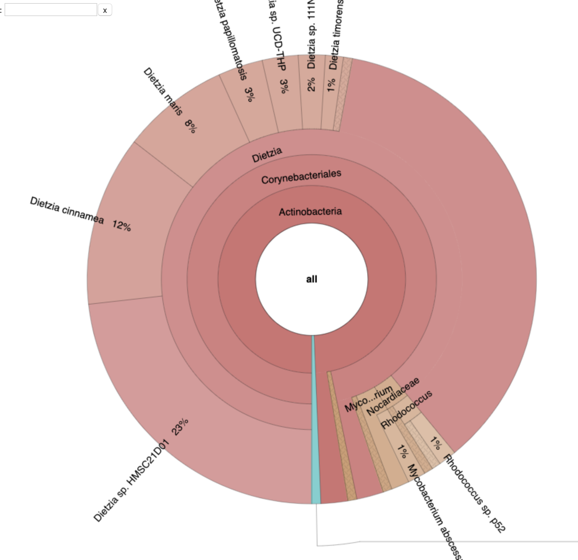
Figure 2.) Krona Taxonomic Chart of Isolate. Chart indicates 95% confidence isolate is from the Dietzia genus

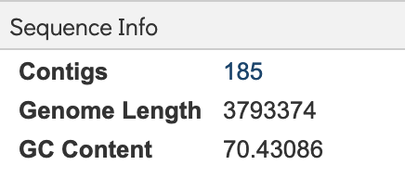
Figure 3.) Isolate Sequence Information from PATRIC generated a genome using 185 contigs and showed a Guanine-Cytosine Content of 70.43%

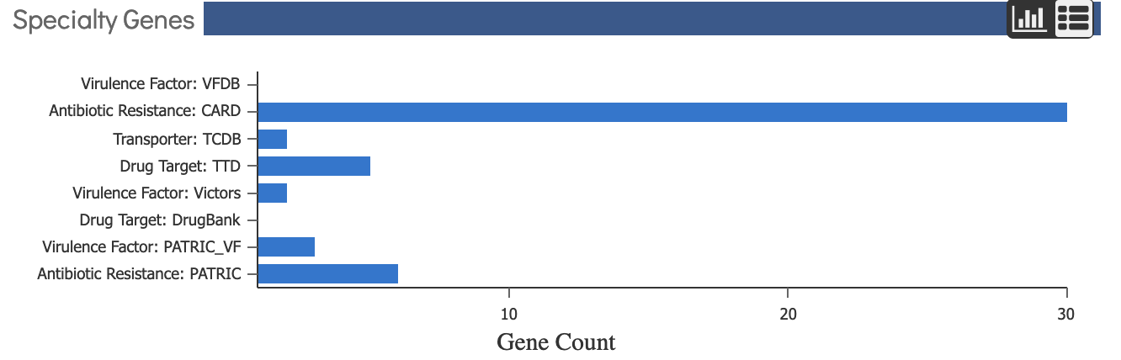
Figure 4.) Virulence and Antibiotic resistance genes in Dietzia maris genome. Genomic analyses resulted in 31 identified antibiotic resistant genes

Successful DNA extraction and subsequent bioinformatic analyses of the of unknown isolate indicated that the identity of the microbe was Dietzia maris. The taxonomic assignment according to the Krona chart yielded by Kaiju indicates that the majority, ~95%, of the extracted DNA was comprised of multiple Dietzia species (Figure 2). The metagenome binning results provided by PATRIC, resulted in one bin with an 89% confidence, indicating that the dominant species in the sample was Dietzia maris (Figure 2). The genome assembly used 185 contigs to assemble a genome with a 3,793,374 bp length and a cytosine guanine percent content (GC%) of 70.43086% (figure 3). Based on specialty genes found in PATRIC, this organism presented with 31 antibiotic resistant genes (Figure 4).

Physiological Testing
Test | Result | Trait Tested
Catalase Test | Positive | Determines Isolate ability to neutralize reactive oxygen species like H202
Oxidase Test | Negative | Determines the presence of cytochrome c oxidase, indicating presence or absence of and aerobic electron transport chain
Fluid Thioglycollate Test | Strictly Aerobic | Oxygen class determinant
Table 1) Physiological Tests of Isolate with Results. Left column represents the name of the test, middle column represents results of each test, and the right column represents a description of the test.

API Coryne test | Results | Reaction tests
NIT | + | Reduction of Nitrates
PYZ | n/a | Pyrazinamidase presence
PYRA | - | Pyrrolidonyl arylamidase presence
PAL | + | Alkaline Phosphatase presence
βGUR | - | β-Glucuronidase presence
βGAL | - | β-Galactosidase presence
αGLU | - | α-Glucosidase presence
βNAG | - | N-Acetyl-β-Glucosaminidase presence
ESC | -- | β-glucosidase (Esculin) presence
URE | - | Urease presence
GEL | - | Hydrolysis (Gelatin)
O  GLU  RIB  XYL  MAN  MAL  LAC  SAC  GLYG | n/a  +  -  -  -  -  -  -  + | Fermentation  Fermentation (Glucose)  Fermentation (Ribose)  Fermentation (Xylose)  Fermentation (Mannitol)  Fermentation (Maltose)  Fermentation (Lactose)  Fermentation (Saccharose)  Fermentation (Glycogen)
CAT | + | Catalase presence
Table 2) API Coryne test with results. Left column represents the name of physiological test on the API Coryne test, the middle column represents the results, and the right column represents what the enzyme or the physiological ability is tested.

The catalase test indicated the presence of the catalase enzyme, an enzyme critical in protecting cell from reactive oxygen species H₂O₂. The oxidase test showed a negative result, no color change, meaning the absence of the cytochrome c oxidase enzyme. After optimal growth in the fluid thioglycollate media, the oxygen class was determined to be strictly aerobic, suggesting no growth in the anoxic region and substantial growth in oxic region (Table 1). API Coryne test results showed five positive physiological abilities which include; glycogen and glucose fermentation, catalase and alkaline phosphatase enzymatic activity, and nitrogen reduction. All additional API tests indicated a negative result (Table 2).

Antibiotic Resistance and Susceptibility
Antibiotic | Zone Diameter Length (mm) | Resistance/Susceptibility
Vancomycin | 32mm | Susceptible
Cefazolin | ≥18mm | Susceptible
Penicillin | ≥29mm | Susceptible
Oxacillin | 0mm | Resistant
Gentamicin | ≥15mm | Susceptible
Cefoperazone | ≥21mm | Susceptible
Tetracycline | ≥19mm | Susceptible
Erythromycin | ≥23mm | Susceptible
Table 3) Antibiotic Resistant and Susceptibility Test with Results. The left column represents the name of the antibiotic, the middle test represents the zone of inhibition diameter length in millimeters, and the right column represents whether the isolate is resistant or susceptible

The disk diffusion test indicated antibiotic susceptibility and resistance capabilities of the isolate. The results show that Dietzia maris has antibiotic resistance to oxacillin but was susceptible to all other antibiotics (Table 3).

Discussion
The results identify the isolate to be Dietzia maris (Figure 2). This contrasts with my prediction that the microbe would be a Streptococcus or Staphylococcus species which are common opportunistic pathogens found on human skin. However, genome analyses indicate that my isolate contains 31 antibiotic resistant genes (Figure 4) confirming my prediction that my isolate will exhibit high numbers of antibiotic resistant genes. Dietzia maris is an interesting bacterium that is found all over the environment. It has been found on the skin and intestinal tract of carp, deep sea hydrothermal fields, and in Russian soils (Nesterenko et al. 1982) (Wang, Cai, and Shao 2014). Additionally, this microbe has been known to be involved in oceanic hydrocarbon bioremediation and biosurfactant production (Wang, Cai, and Shao 2014). Physiological testing of Dietzia maris correlates with findings of similar studies. Specifically, the GC content for my isolate was 70.4%, falling within the GC content range (66-73%) of Dietzia maris reported by Pidoux et al. and Koerner et. al. (Koerner, Goodfellow, and Jones 2009; Pidoux et al. 2001). Additionally, physiological characteristics such as being strictly aerobic, presence of catalase, smooth orange colony with coccoid cell morphology, and Gram positive classification of Dietzia maris correlate with literature results (Koerner, Goodfellow, and Jones 2009, Bemer-Melchior et al. 1999; Pidoux et al. 2001). As a strictly aerobic microbe, Dietzia maris surprisingly tested negative for cytochrome c oxidase enzyme, a critical enzyme for aerobic electron transport chain, however other studies received the same results (Yassin 2006). API Coryne test results indicated the presence of alkaline phosphatase and catalase enzymes (Table 2). This test also tested positive for physiological abilities such as nitrate reduction and fermentation of glucose and glycogen (Table 2). Prior studies using the API Coryne test have consistently found Dietzia maris to possess nitrate reductase, catalase, alkaline phosphatase, as well as α-Glucosidase, an enzyme that tested negative on our API strip (Hirvonen et al. 2012) (Pidoux et al. 2001). Other contrasting findings include fermentation of certain sugars. Our results indicate that Dietzia maris is capable of fermenting glucose and glycogen, however, no other studies found the same result.
Through the lens of human health, Dietzia maris has been found to be opportunistically pathogenic to humans, causing infection and in some cases leading to septicemia (Pidoux et al. 2001; Bemer-Melchior et al. 1999). Additionally, a case study from Reyes et al. in 2006 observed a patient who died from an aortic dissection due to the growth of Dietzia maris in the adventitial layer of the descending aorta. This resulted in the weakening of the aortic wall, and eventually causing the aorta to burst leading to severe internal bleeding and death (Reyes et al. 2006). The pathogenicity of Dietzia maris highlights the importance of treatment, and how effective antibiotics are. A study conducted by Pioux et. al. indicated that antibiotics such as amoxicillin, imipenem, gentamicin, pristinamycin, rifampin, clindamycin, and vancomycin are effective for treating Dietzia spp. infections (Pidoux et al. 2001). However, recent case studies have shown D. maris to be resistant to antibiotics such as sulfamethoxazole, a folate synthesis inhibitor (Hitchings 1973) (Pilares et al. 2010). Overall, our results indicate that Dietzia maris is susceptible to Vancomycin, Cefazolin, Penicillin, Gentamicin, Cefoperazone, Tetracycline, and Erythromycin (Table 3), however, our results also show resistance to oxacillin, a cell wall synthesis inhibitor (Papich 2016). Interestingly, Koerner et al. found Dietzia maris to be susceptible to oxacillin using the same disc diffusion technique (Koerner et al. 2009). These contrasting results with the presence of 31 antibiotic resistant genes (Figure 4) hint that our isolate was able to gain an antibiotic resistance gene to oxacillin possibly from an oxacillin-resistant microbe that was cultured on the initial swab from the UAF sauna (Figure 1).

Bibliography
Barker, J., and S. F. Bloomfield. 2000. “Survival of Salmonella in Bathrooms and Toilets in Domestic Homes Following Salmonellosis.” Journal of Applied Microbiology 89 (1): 137–44.
Bemer-Melchior, P., A. Haloun, P. Riegel, and H. B. Drugeon. 1999. “Bacteremia Due to Dietzia Maris in an Immunocompromised Patient.” Clinical Infectious Diseases. https://doi.org/10.1086/313490.
Bisno, A. L., and D. L. Stevens. 1996. “Streptococcal Infections of Skin and Soft Tissues.” The New England Journal of Medicine 334 (4): 240–45.
Chow, Janet, S. Melanie Lee, Yue Shen, Arya Khosravi, and Sarkis K. Mazmanian. 2010. “Host-Bacterial Symbiosis in Health and Disease.” Advances in Immunology 107: 243–74.
Flores, Gilberto E., Scott T. Bates, Dan Knights, Christian L. Lauber, Jesse Stombaugh, Rob Knight, and Noah Fierer. 2011. “Microbial Biogeography of Public Restroom Surfaces.” PloS One 6 (11): e28132.
Hirvonen, Jari J., Inari Lepistö, Sointu Mero, and Suvi-Sirkku Kaukoranta. 2012. “First Isolation of Dietzia Cinnamea from a Dog Bite Wound in an Adult Patient.” Journal of Clinical Microbiology 50 (12): 4163–65.
Hitchings, G. H. 1973. “Mechanism of Action of Trimethoprim-Sulfamethoxazole--I.” Journal of Infectious Diseases. https://doi.org/10.1093/infdis/128.supplement_3.s433.
Koerner, Roland J., Michael Goodfellow, and Amanda L. Jones. 2009. “The Genus Dietzia: A New Home for Some Known and Emerging Opportunist Pathogens.” FEMS Immunology and Medical Microbiology 55 (3): 296–305.
Marshall, Bonnie M., Dorothy J. Ochieng, and Stuart B. Levy. 2009. “Commensals: Underappreciated Reservoir of Antibiotic Resistance.” Microbe Magazine. https://doi.org/10.1128/microbe.4.231.1.
Mkrtchyan, Hermine V., Charlotte A. Russell, Nan Wang, and Ronald R. Cutler. 2013. “Could Public Restrooms Be an Environment for Bacterial Resistomes?” PloS One 8 (1): e54223.
Nesterenko, O. A., T. M. Nogina, S. A. Kasumova, E. I. Kvasnikov, and S. G. Batrakov. 1982. “Rhodococcus Luteus Nom. Nov. and Rhodococcus Maris Nom. Nov.” International Journal of Systematic Bacteriology. https://doi.org/10.1099/00207713-32-4-469b
Papich, Mark G. Saunders Handbook of Veterinary Drugs: Small and Large Animal. Philadelphia: Saunders, 2016..
Pidoux, O., J. N. Argenson, V. Jacomo, and M. Drancourt. 2001. “Molecular Identification of a Dietzia Maris Hip Prosthesis Infection Isolate.” Journal of Clinical Microbiology 39 (7): 2634–36.
Pilares, Lilian, Jesús Agüero, José A. Vázquez-Boland, Luis Martínez-Martínez, and Jesús Navas. 2010. “Identification of Atypical Rhodococcus-like Clinical Isolates as Dietzia Spp. by 16S rRNA Gene Sequencing.” Journal of Clinical Microbiology 48 (5): 1904–7.
Reyes, Guillermo, José-Luis Navarro, Carlos Gamallo, and María-Carmen delas Cuevas. 2006. “Type A Aortic Dissection Associated with Dietzia Maris.” Interactive Cardiovascular and Thoracic Surgery 5 (5): 666–68.
Tenover, Fred C., and Michele L. Pearson. 2004. “Methicillin-Resistant Staphylococcus Aureus.” Emerging Infectious Diseases 10 (11): 2052–53.
Wang, Wanpeng, Bobo Cai, and Zongze Shao. 2014. “Oil Degradation and Biosurfactant Production by the Deep Sea Bacterium Dietzia Maris As-13-3.” Frontiers in Microbiology 5 (December): 711.
Wertheim, Heiman F. L., Damian C. Melles, Margreet C. Vos, Willem van Leeuwen, Alex van Belkum, Henri A. Verbrugh, and Jan L. Nouwen. 2005. “The Role of Nasal Carriage in Staphylococcus Aureus Infections.” The Lancet Infectious Diseases 5 (12): 751–62.
Yassin, A. F. 2006. “Dietzia Cinnamea Sp. Nov., a Novel Species Isolated from a Perianal Swab of a Patient with a Bone Marrow Transplant.” INTERNATIONAL JOURNAL OF SYSTEMATIC AND EVOLUTIONARY MICROBIOLOGY. https://doi.org/10.1099/ijs.0.63863-0.

